Radiograph Information for Patients

Rankin & Fiume Orthodontics offers an exciting technology for our patients and for patients of other doctors who might be referred to our office. This technology is known as CBCT (Cone Beam Computed Tomography) 3D Imaging.

Using 3D imaging means we now have the ability to view images of the teeth, jaws, bones, and facial structures in 3D with the opportunity of improved diagnosis for our patients. Understandably you may have questions about exposure to these types of x-rays. Please see the graph below on estimated effective dosage comparisons from various types of radiation.

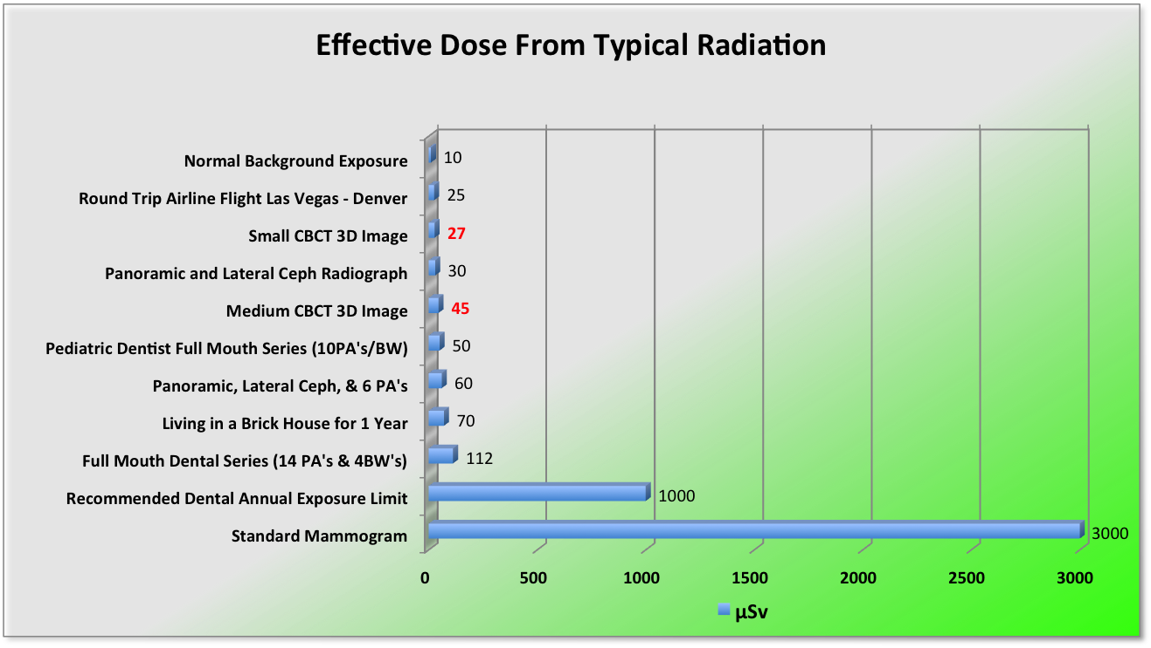

Small and Medium CBCT 3D Imaging (highlighted in red in the chart above) refers to the most common CBCT Scans taken in our office. 3D Imaging offers our patients enhanced orthodontic diagnostic value. As dentists and orthodontists we evaluate teeth, jaws, and immediate surrounding/supporting bone using 3D Imaging for those limited purposes.

We are pleased to provide this technology in our practice as part of our routine orthodontic care. Please let us know if you have any other questions.

Thank you,

Dr. Todd Rankin, Dr. Len Fiume, and our Orthodontic Team

